?
Cognitive Domain

Social Background
Social Background

INDIVIDUAL INDIVIDUAL

STYLE STYLE

CLIENT ROLE
Attitudes
Covert/Overt motives
Goals & time frame
Stereotypes - occupational, gender, cultural
Anxiety – anomalous state of knowledge
Process
Seeker Cues to Learning Style
Verbal & Nonverbal - tone, language, eyes, gestures, facial expression, body-placement
“Educational Cognitive Style” - HILL
M - categorical, black/white, stepwise
D - hypotheses of difference, either/or
R - interrelationships, commonalities
L - equal use of above three
K - deductive reasoning, premises, logic

LIBRARIAN ROLE
Professional Philosophy in Library Context

Learning Theories
Constructivist or Cognitve - empowers student
Behavioralist - old & source-centered
Developmental

Levels of Service
Conservative/Moderate/Liberal –

Diversity - aware of seeker’s complex needs

Customization
Library Skills Instruction
Resource centered – Source approach
Pathfinder approach
User centered – Process approachUse
Intervention Levels – Kuhlthau
Organizer
Lecturer
Instructor
Tutor
Counselor - Process instruction & most service
Assessment & Repackaging



GOAL

Cognitive reflexivity and clients
who are active participants in their
learning and in the development
of a personalized search process.

TECHNOLOGY
Challenges & Opportunities
THEORETICAL MODELS
Diagnostic, Learning, and Communication Models



Information Search Process Models

Kuhlthau – User perspective & empirical –7 Stages/Affective/Cognitive/Behavioral
Irving’s “Study & Info Skills Across Curriculum – 9 Steps/Activities/Central ?s

Stripling & Pitts – 10 Steps/Research Tasks/Questions for Reflection/REACTS
Joyce & Tallman’s I-Search – learning logs, webbing, interaction, personal interest
Pappas & Tepe’s Pathways to Knowledge – webs, outlines, clustering ideas, holistic
Eisenberg & Berkowitz’s Big Six Skills – Also Super 3 & Little 12 applicable as a
systematic process of thinking for all ages

Diagnosis Prescription Treatment Evaluation
COMMUNICATION MODELS

REACTS MODEL

RECALLING
Fact finding

EXPLAINING
Asking & searching

ANALYZING
Examining & organizing

CHALLENGING
Evaluating & deliberating

TRANSFORMING
Integrating & concluding
SYNTHESIZING
Conceptualizing
TAYLOR - Compromised Query
visceral – conscious – formal – compromised
DERVIN - Sense Making & Neutral Questioning
describe situation – identify gaps – discuss info use
BELKIN - Anomalous States of Knowledge
reluctance to ask for assistance, describe known

Bloom’s Taxonomy
Recognition
Knowledge
Comprehension
Application
Analysis
Synthesis
Evaluation
CYCLE OF SERVICE
GROVER

FOUNDATION

Technology

OPPORTUNITIES

Ever-Expanding Innovation

Global Village

Value-Added Service

Access versus being a book warehouse

Consortiums / Cooperative Ventures

CHALLENGES

Cost / Funding

Digital Divide

Information literacy

Information Overload

Copyright Issues

Diffusion of Technology (Rogers)

Demand for Immediacy





Hemisphericity
Right - Visuo-Spatial, Random, Emotional, Intuitive, Divergent
Left - Verbal, Sequential, Objective, Rational, Convergent
Learning Style Inventory - David COLB
Concrete Experiencers Reflective Observers
Abstract Conceptualizers Active Experimenters

Meyers-Briggs Type Indicator - MBTI
E / I Extraversion - Introversion S / I Sensing - Intuition
T / F Thinking - Feeling J / P Judging - Perceiving

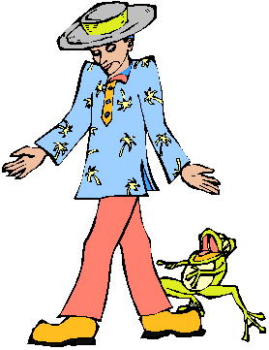

GENDER

understanding, subjective
personal, relational

impersonal, rational, objective

Lev VYGOTSKY
Zones of Proximal Development Theory
Independent & actual learning level is expanded to potential level with assistance

PERSONALITY
A person’s occupation
is a good predictor of
his personality style.
- Stein, Hand, Totten (1986)

DEVELOPMENTAL STAGES OF LEARNING
Stages of cognitive development to age fifteen - Jean PIAGET
1 Sensorimotor 2 Preoperational

3 Concrete operations 4 Formal operations

Psychosocial stages of human development - Erik ERICKSON
1 Infancy Trust vs. mistrust Hope
2 Early childhood Autonomy vs. shame/doubt Will
3 Play age Initiative vs. guilt Purpose
4 School age Industry vs. inferiority Competence
5 Adolescence Identity vs. identity confusion Fidelity
6 Young adulthood Intimacy vs. isolation Love
7 Maturity Generative vs. self absorption Care
8 Old age Integrity vs. despair Wisdom

OCCUPATION

Career Theory
Self-Selection - matches self-perceptions/ permits self-expression
Socialization - adhere to values/roles, which results in change

Multiple Intelligences - Howard GARDNER
Verbal Linguistic Logical Mathematical
Visual Spatial Bodily Kinesthetic
Musical Rhythmic Naturalist
Interpersonal Intrapersonal

A
G

E

Daniel LEVINSON

5 Stages or Eras

- Pre-adulthood birth - 20
- Early adulthood 17 - 45
- Middle adulthood 40 - 64
- Late adulthood 50 - 88
- Late-late adulthood 80 +



Stages of Moral Development

Lawrence KOHLBERG

Pre-conventional
- Obedience & Punishment
2 Individualism, Instrumentalism, & Exchange

Conventional
3 “Good boy/girl”
4 Law & Order

Post-conventional
5 Social Contract
6 Principled Conscience

Joseph Cambell
Myth

Carl Jung - Archetypes
Belief System


Hierarchy of Human Needs
Abraham MASLOW
V - VI - VII
Self Actualization
Need to Know
Need for Beauty and Order
IV
Esteem Needs
III
Love and Belonging Needs
II
Safety and Security Needs
I
Physiological Needs

LANGUAGE


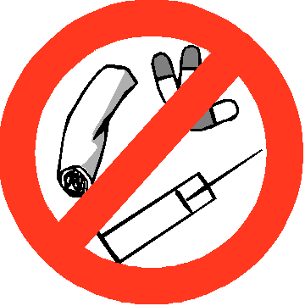

Socio/Economic Factors
Info & Basic Literacy
In
Behaviorist Theory of Learning - B. F. SKINNER
Pleasant Experiences = Positive Reinforcement / Continuous reinforcement increases learning / Lack and type of reinforcement shapes behavior
Classical Conditioning – Ivan PAVLOV stimulus-response association
ECONOMIC POVERTY



Theory of Attachment & Early Childhood Identity Development
Margaret MAHLER

* Normal autistic phase
* Normal symbiotic phase

Subphases of Separation - Individuation Proper
1 Differentiation
2 Practicing
3 Rapprochement
4 Object constancy

